DBMS LAB FILE

Name: Reinaldo

Roll No: 44

1)

Aim: To create a database dbms_44

Query:

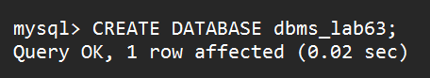

Output:

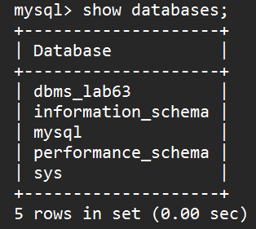

2) Aim: To drop a database

Query:

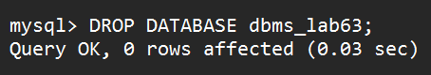

Output:

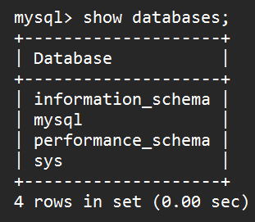

3) Aim: To use a Database

Query and Output:

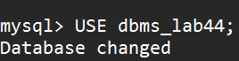

4) Aim:To check the status of your Database

Query:



Output:

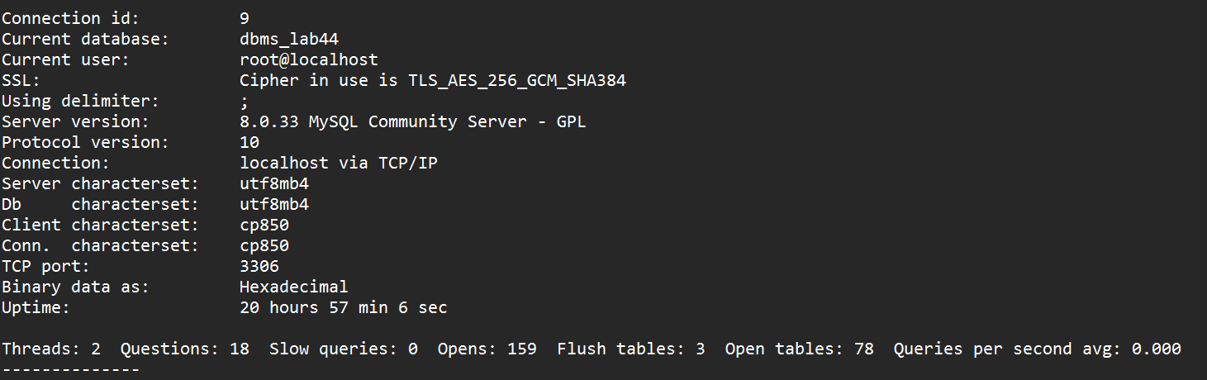

5) Aim: To create a table student

Query:



Output:

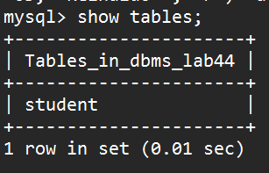

6) Aim : To Insert Values into Table student

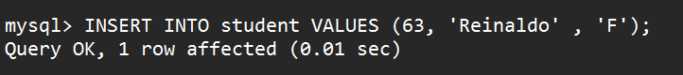

Query:

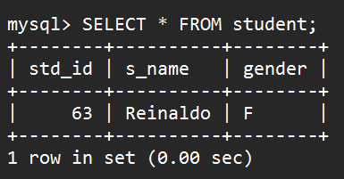

Output:

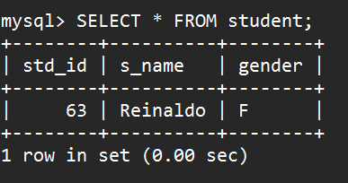

7) Aim: To describe table student

Query and Output:

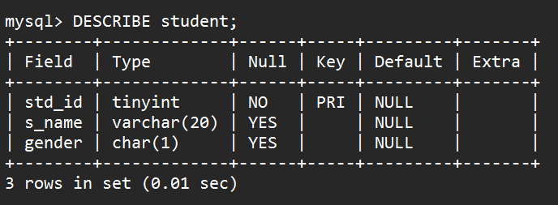

8) Aim: to Insert values into table student

Query:

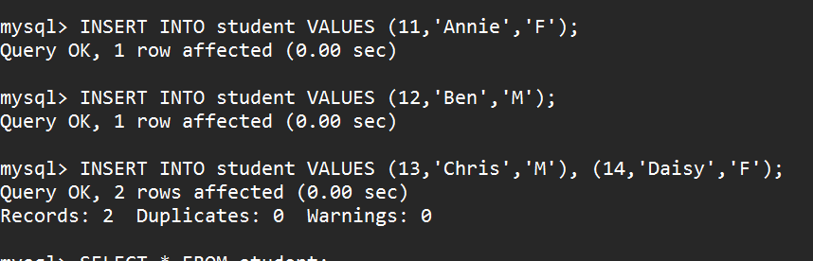

Output

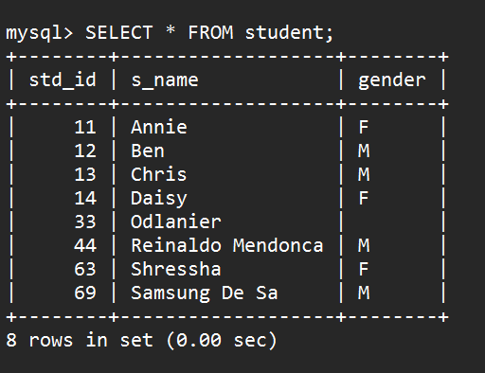

9) Aim: To delete values from table student

Query:

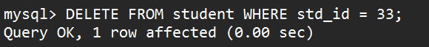

Output:

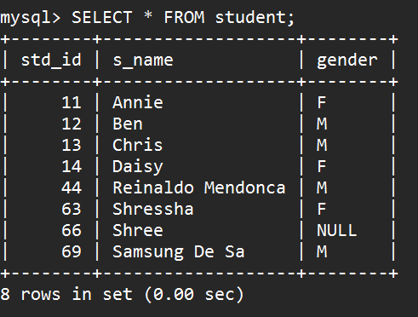

10)Aim: To Add an extra Column DOB to table student

Query:

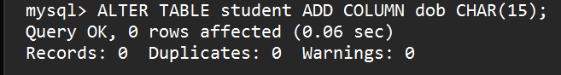

Output:

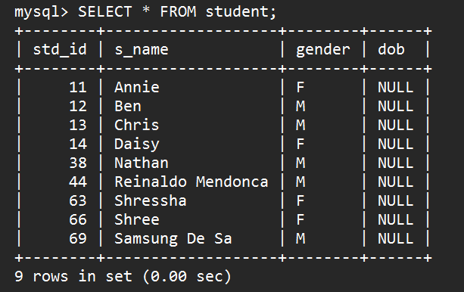

11)Aim: to Update the DOB from NULL to some Date

Query:

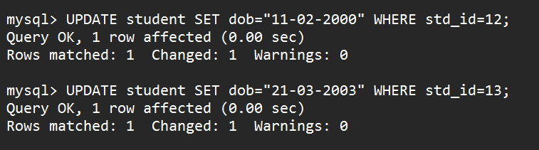

Output:

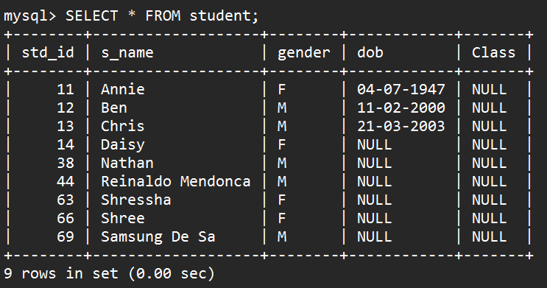

12)Aim: To Make the Student name Not NULL

Query:

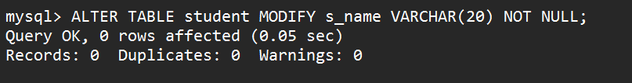

Output:

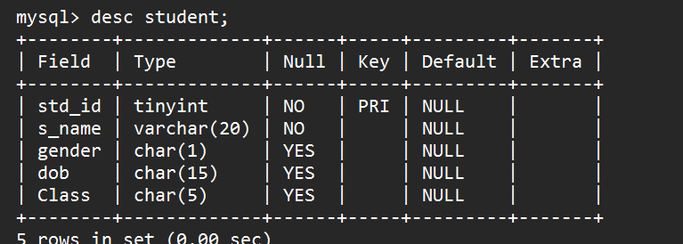

13)Aim: To Add a column Class to the student table

Query:

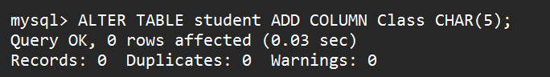

Output:

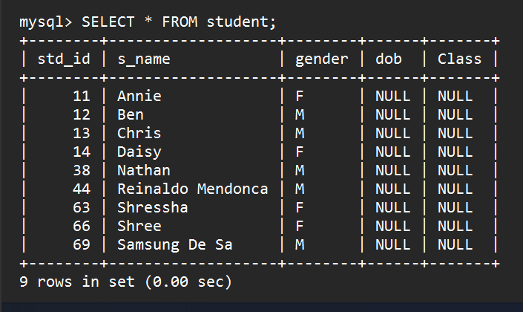

14)Aim: to update the class of the student

Query:

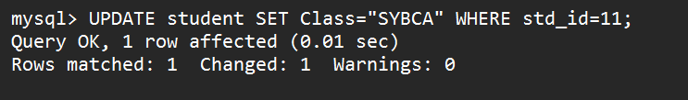

Output:

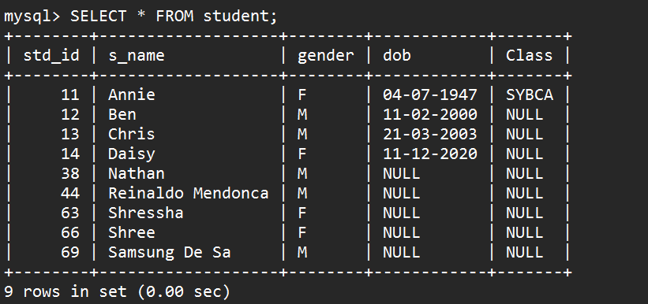

**SALES DATABASE**

**1)Aim : Create a Database Sales**

**Query:**

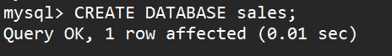

**Output:**

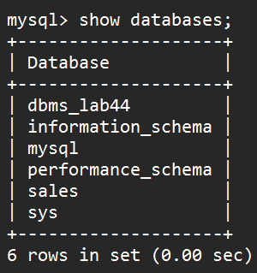

**2)Aim Create Tables Salesman, Product, Client, Sales_order, order_details.**

**Query:**

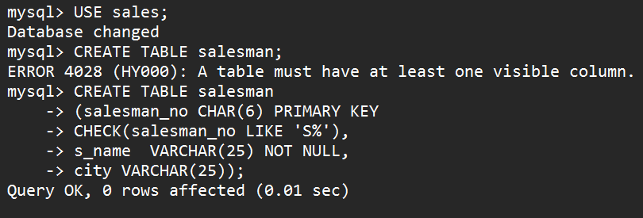

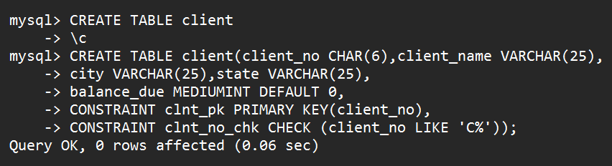

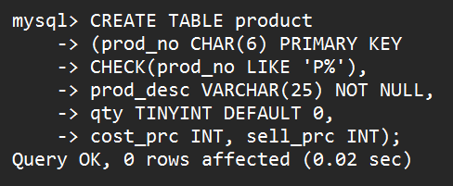

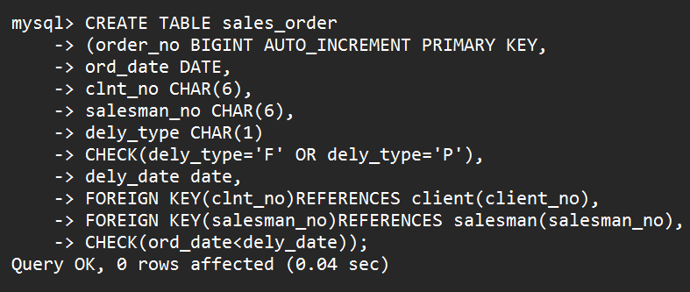

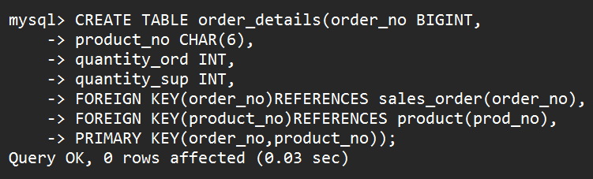

**Output:**

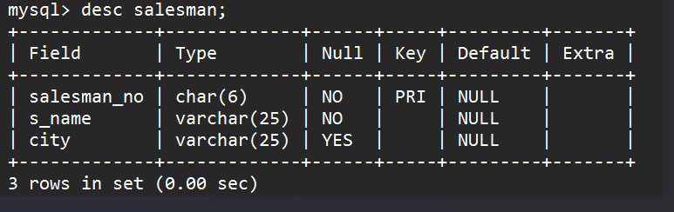

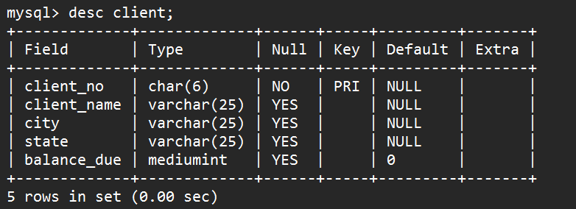

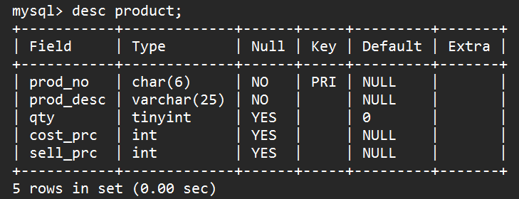

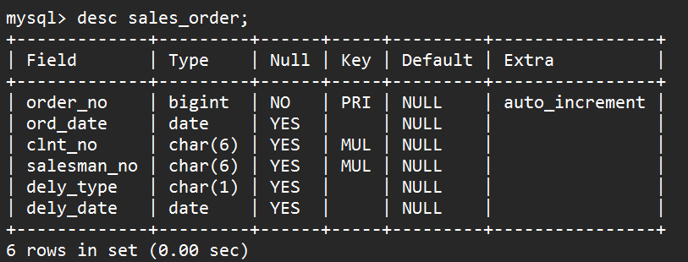

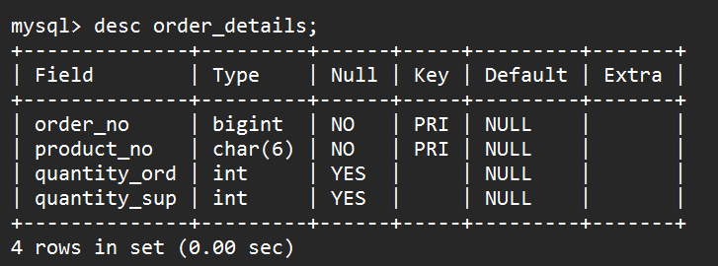

**3)Aim:Insert Values into the salesman, client, product , sales_order and order_details tables.**

**Query:**

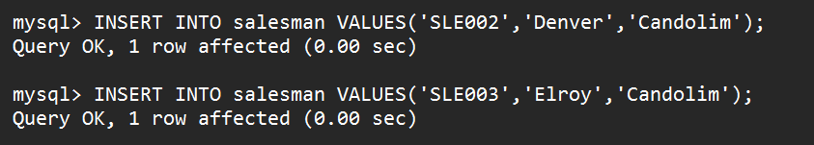







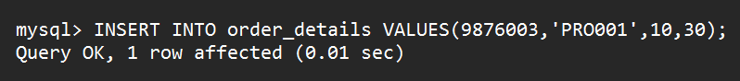

**Output:**

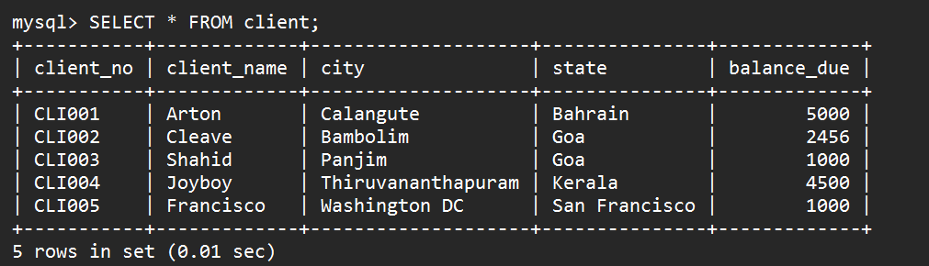

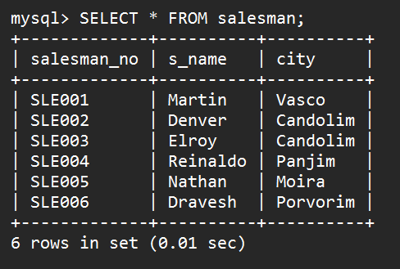

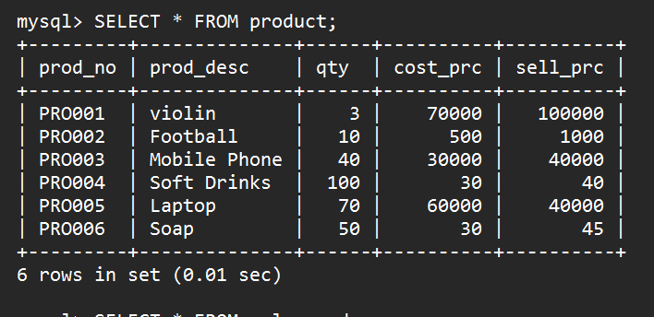

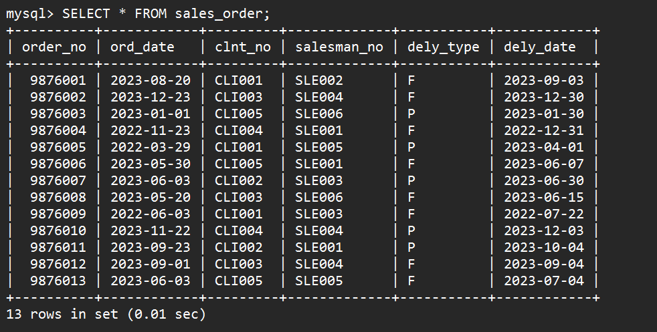

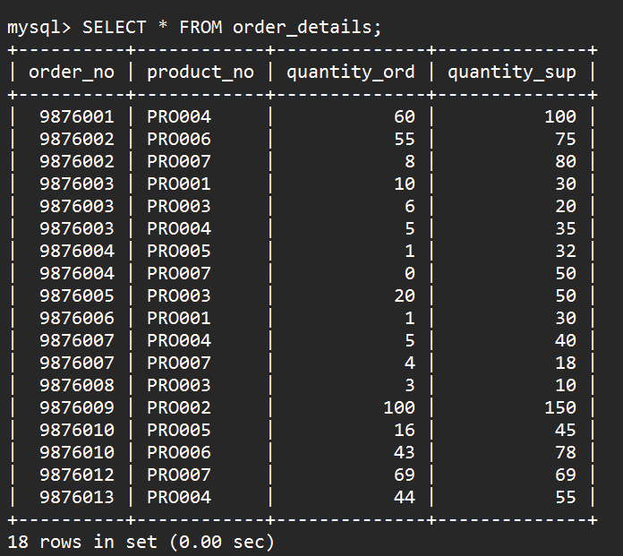

**DOING SOME QUERIES OF SALES DATABASE**

**Query 1:**

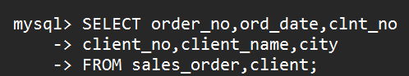

**Output 1:**

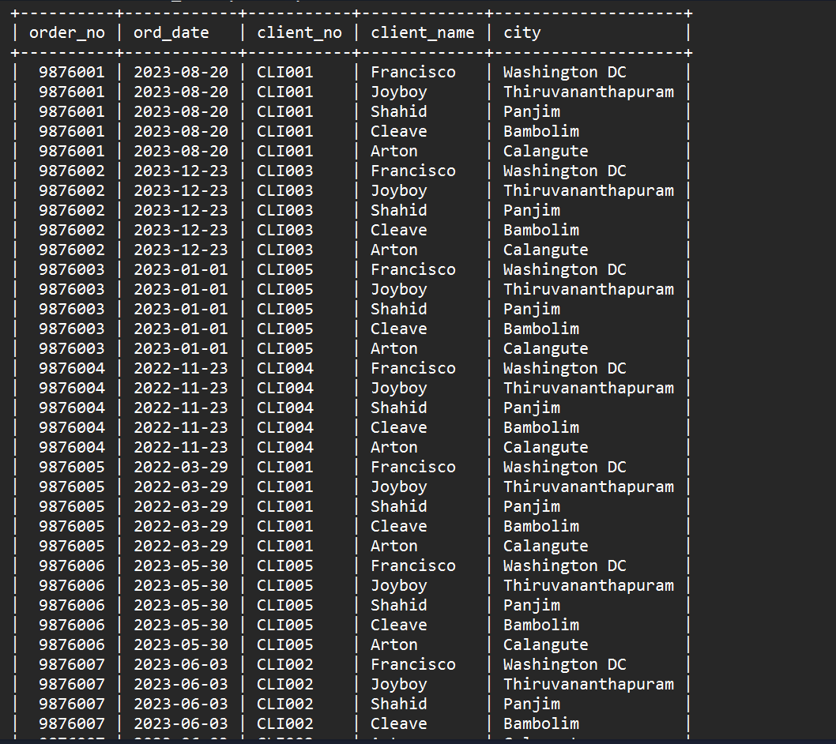

**Query 2:**

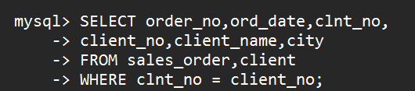

**Output 2:**

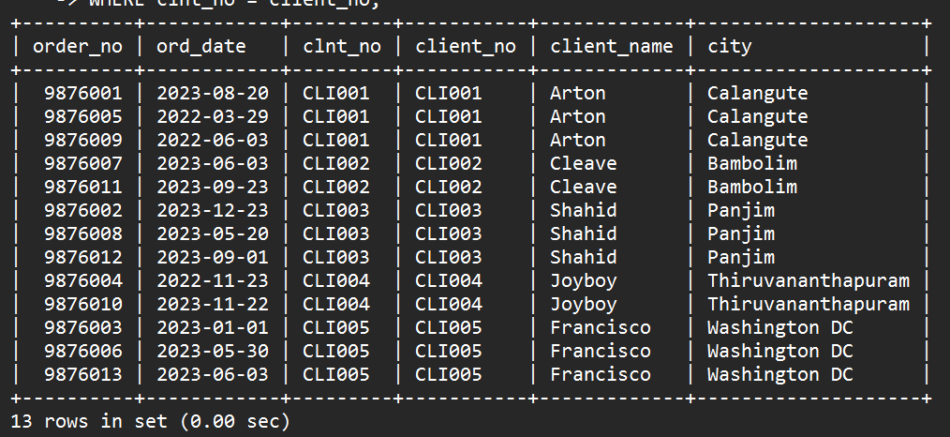

**Query 3:**



**Output 3:**

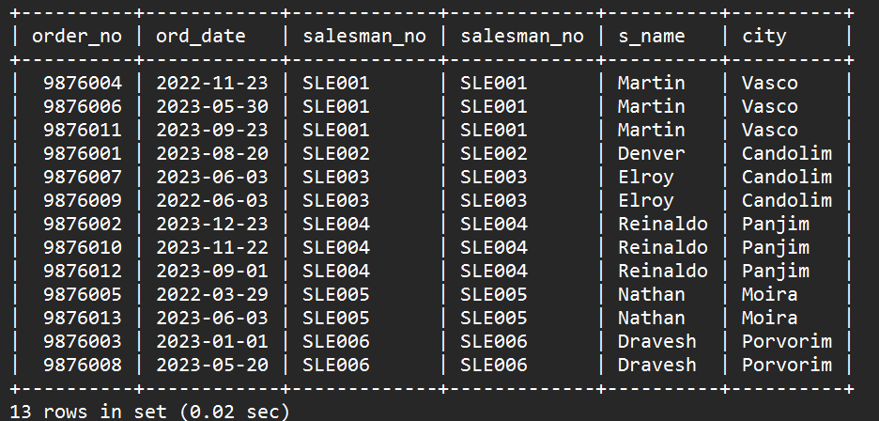

**Query 4:**

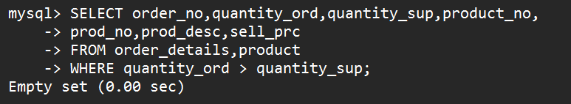

**Query 5:**



**Output 5:**

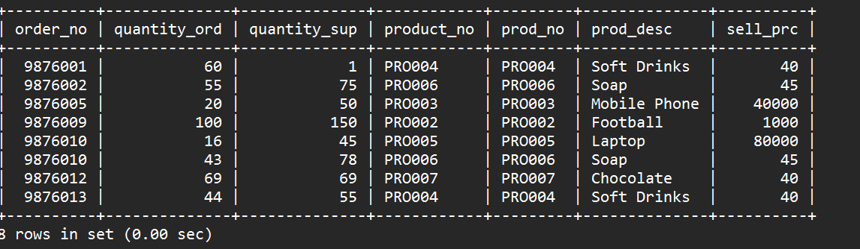

**Query 6:**



**Output 6:**

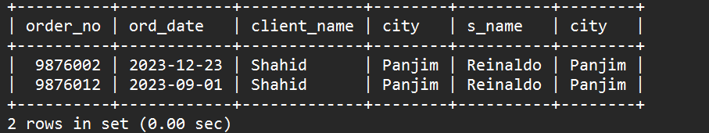

**Query 7:**



**Output 7:**

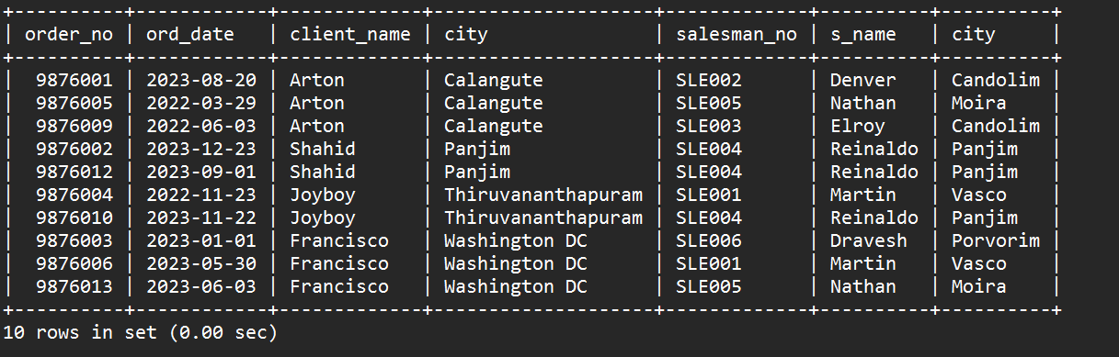

**Query 8:**



**Output 8:**

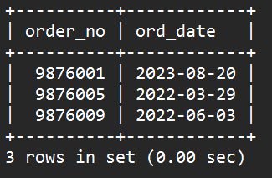

**Query 9:**



**Output 9:**

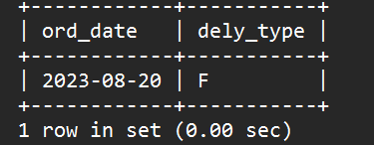

**Query 10:**



**Output 10:**

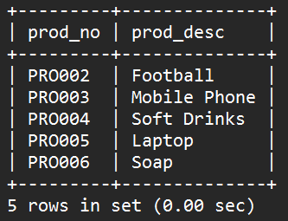

**Query 11:**



**Output 11:**

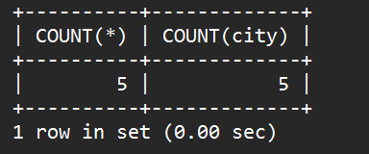

**Query 12:**



**Output 12:**

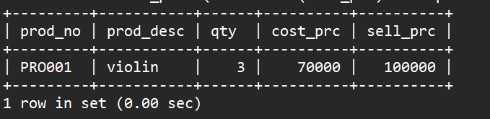

**Query 13:**



**Output 13:**

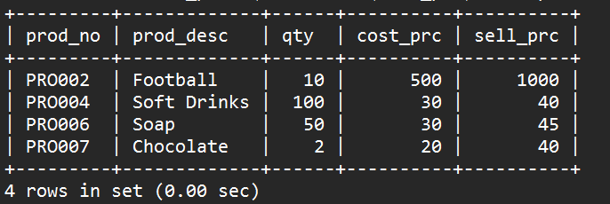

**Query 14:**



**Output 14:**

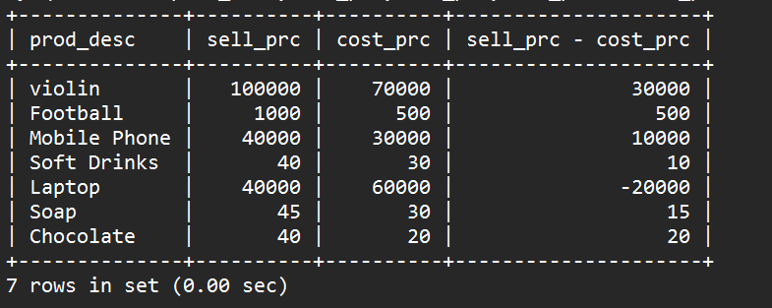

**Query 15:**



**Output 15:**

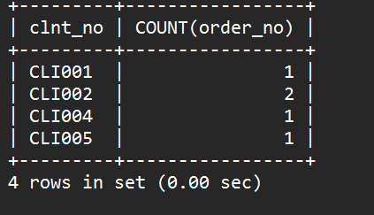

**Query 16:**



**Output 16:**

